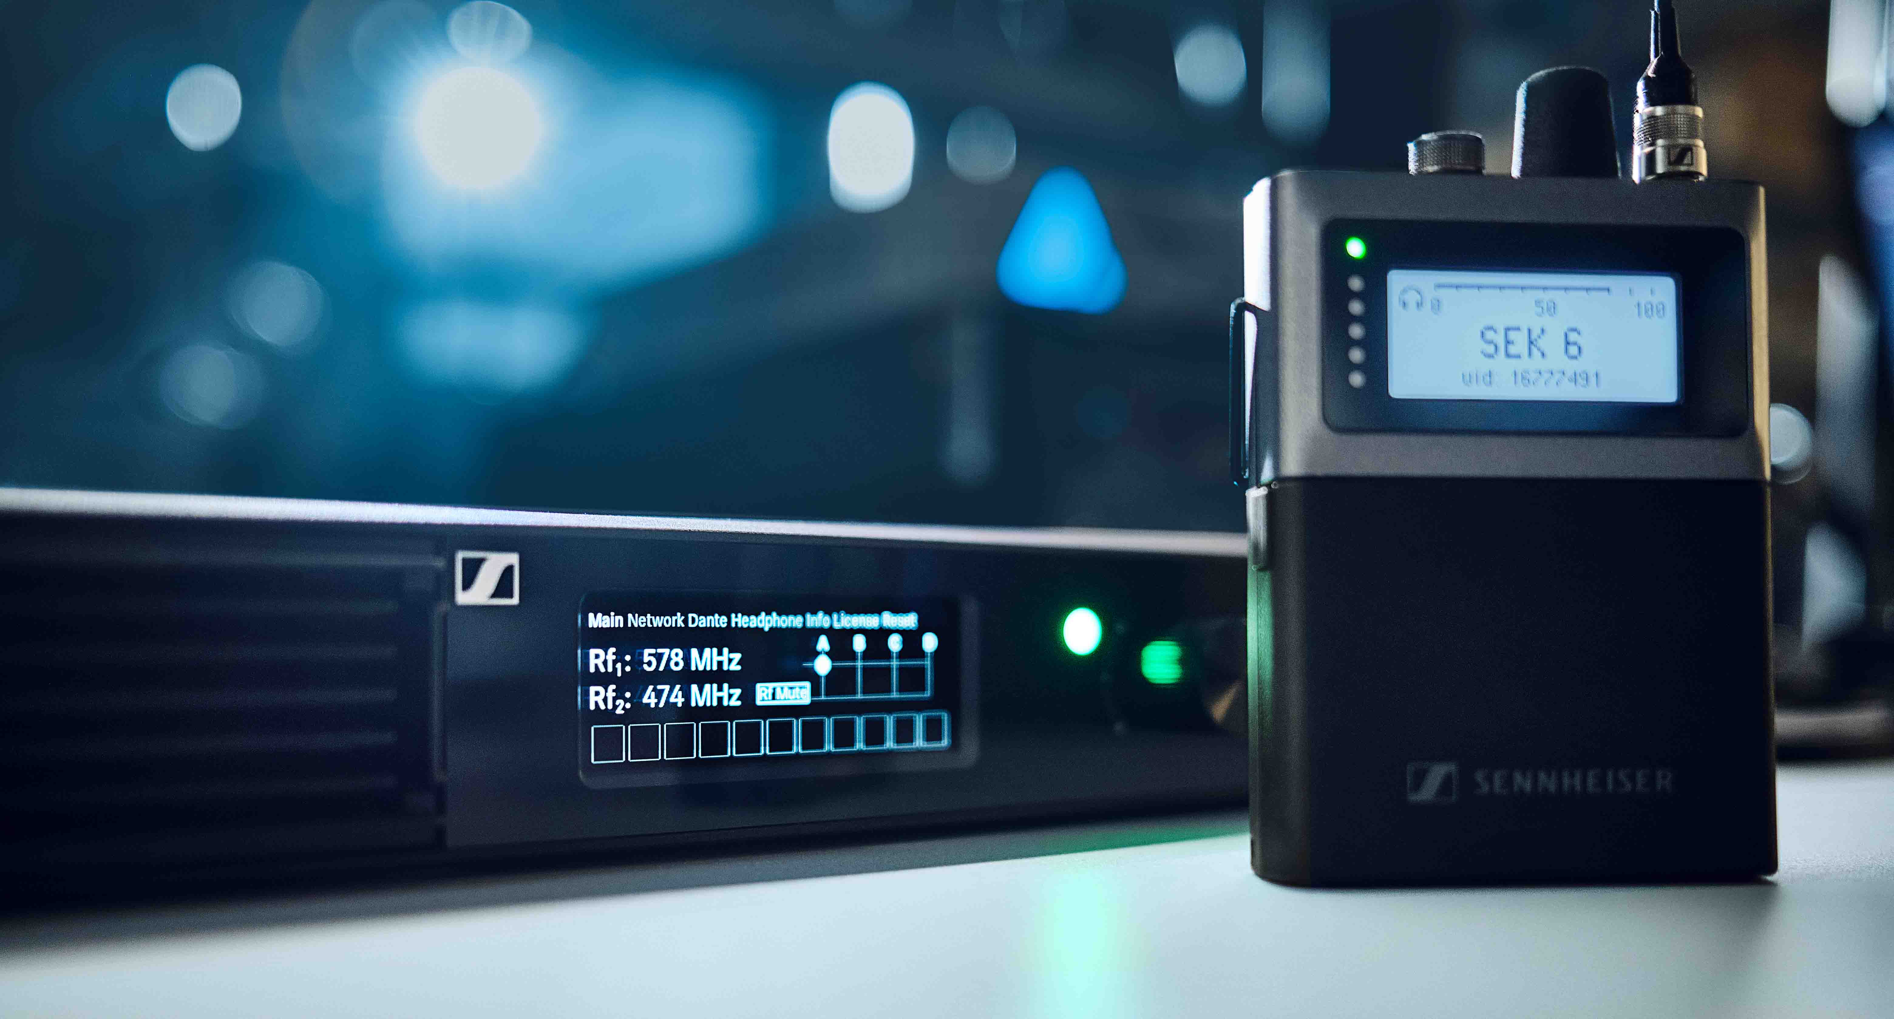

Sennheiser Spectera shipping now
True WMAS technology simplifies live audio productions

Wedemark, 24 April 2025 – Sennheiser has announced today that shipping for its Spectera wideband wireless ecosystem commences on 25 April. By putting the power of a multichannel system into a single 1U rack unit, and accommodating wireless mics, IEMs, and control data in the very same RF channel and a single bodypack, the bidirectional solution will offer unprecedented ease of use for both RF managers and the entire audio team. The hardware includes the Base Station, the bidirectional SEK bodypack, in versions for the TV-UHF and 1.4 GHz bands, the DAD transceiving antennas (also in TV-UHF and 1.4 GHz versions), MADI cards and various accessories. The software for the ecosystem includes the LinkDesk software and the browser-based Spectera WebUI.

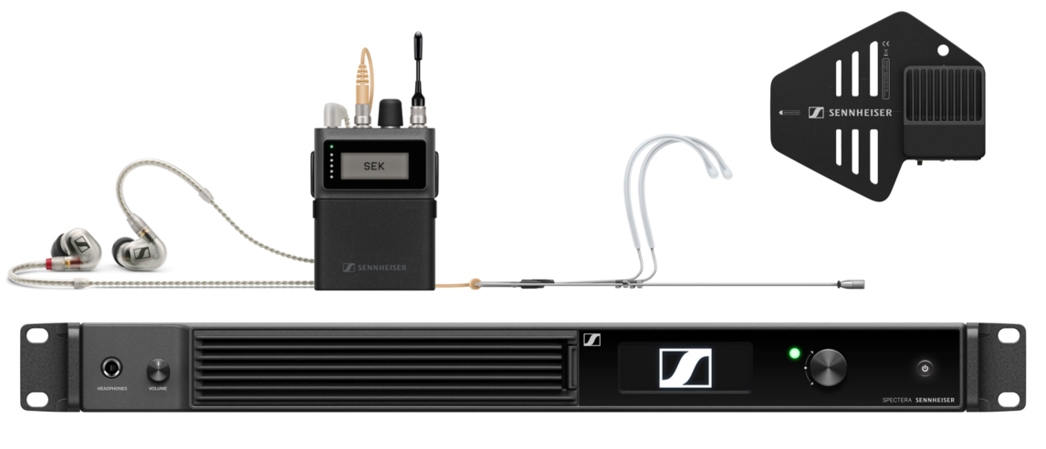 | Sennheiser Spectera bidirectional wideband wireless solution (pictured is the 1.4 GHz version of the bodypack and the antenna)

“As a growing and flexible ecosystem, Spectera will continue to be expanded and modelled on current and upcoming customer and user benefits, and we are extremely happy to start series production and shipping,” says co-CEO Dr Andreas Sennheiser. “I would like to take this opportunity to sincerely thank all participants in the Pioneer Program for their contribution to shaping Spectera, and all our customers for taking this bold step into the future of wireless with us.

“At the same time, I need to ask our customers for patience and understanding, as it will take some time to fulfil the long list of outstanding preorders. At our end, we have invested massively in the electronics production at our plant in Germany and have considerably increased our capacities, but due to the high demand, order fulfilment will inevitably take time.”

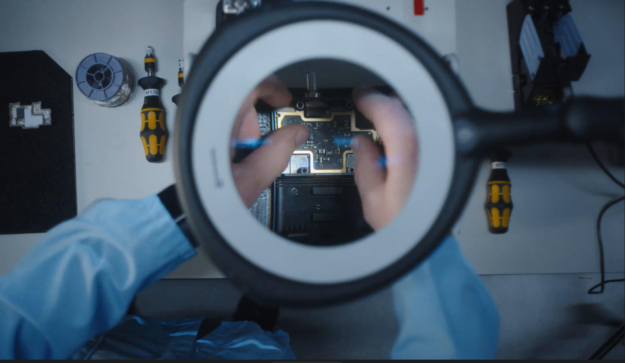 | Series production for Spectera has started

True WMAS solution simplifies live audio productions
From the ecosystem’s small footprint in the warehouse, in transit and backstage, to the automatic coordination of all mobile devices in the 6 or 8 MHz wide RF channel assigned to it, Spectera solves many of the issues that owners and operators of narrowband multichannel wireless systems are faced with today. Setup time with Spectera is greatly reduced, because the extensive frequency calculation and RF cabling of narrowband systems, as well as the complex calculation of power levels for multichannel IEMs, are no longer required with this wideband solution.

“We have had so many happy comments from our Spectera Pioneers, saying that it was a totally new experience for them to be set up and ready so quickly,” says Benedikt Euen, senior product manager at Sennheiser. “Before Spectera, everybody on a production had to wait for them, now they are the ones with time on their hands!”

Spectera allows operators to put both IEMs and mics in the very same TV channel – no separate bands with guard bands anymore. With Spectera offering permanent two-way communication, engineers have full remote control of the wireless system for settings and monitoring, including permanent spectrum sensing, also on the RF channel used by Spectera itself. Thanks to the ecosystem’s low spectral density, it is easier to reuse frequencies than with narrowband wireless, for example between neighbouring theatres.

T6 | 

Productions become totally flexible in the use of the frequency resources allocated to Spectera, and can choose between various Audio Link Modes to determine the ideal audio quality, latency, channel count, and operating range for each and every audio link. Mics and IEMs can easily be added during a show, and thanks to the RF components being part of the DAD transceiving antennas (and not the Base Station), the system does not require any boosters, splitters or combiners.

LinkDesk Software and Spectera WebUI
The all-new LinkDesk desktop application unlocks the Base Station with the correct, region-specific license, and turns a Mac or PC into a centralized remote control and monitoring centre, with an intuitive and user-friendly workflow for multiple Spectera Base Stations. The software gives the operator comprehensive configuration capabilities, routing and zoning features, such as a choice of Audio Link Modes with varying levels of audio quality, latency, possible audio links and range.

The LinkDesk software turns a Mac or PC into a control and monitoring centre for multiple Base Stations | 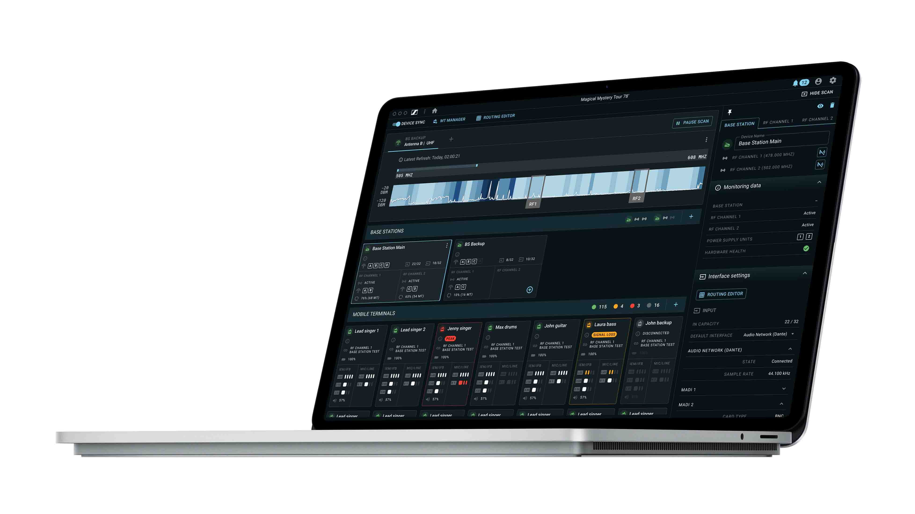

While LinkDesk is the recommended tool for any larger Spectera setup, an individual Base Station can also be monitored and controlled via the browser-based Spectera WebUI. Designed as a streamlined web interface, Spectera WebUI allows system access to the Base Station from any device – phone, tablet, or computer – for easy setup, configuration, monitoring, and firmware updates.

In future, Spectera will also be integrated into the brand-neutral SoundBase RF planning tool, allowing the coordination of both wideband and narrowband wireless in one software. A mode planner is already available via SoundBase Tools.

Spectera WebUI in use at a live show | 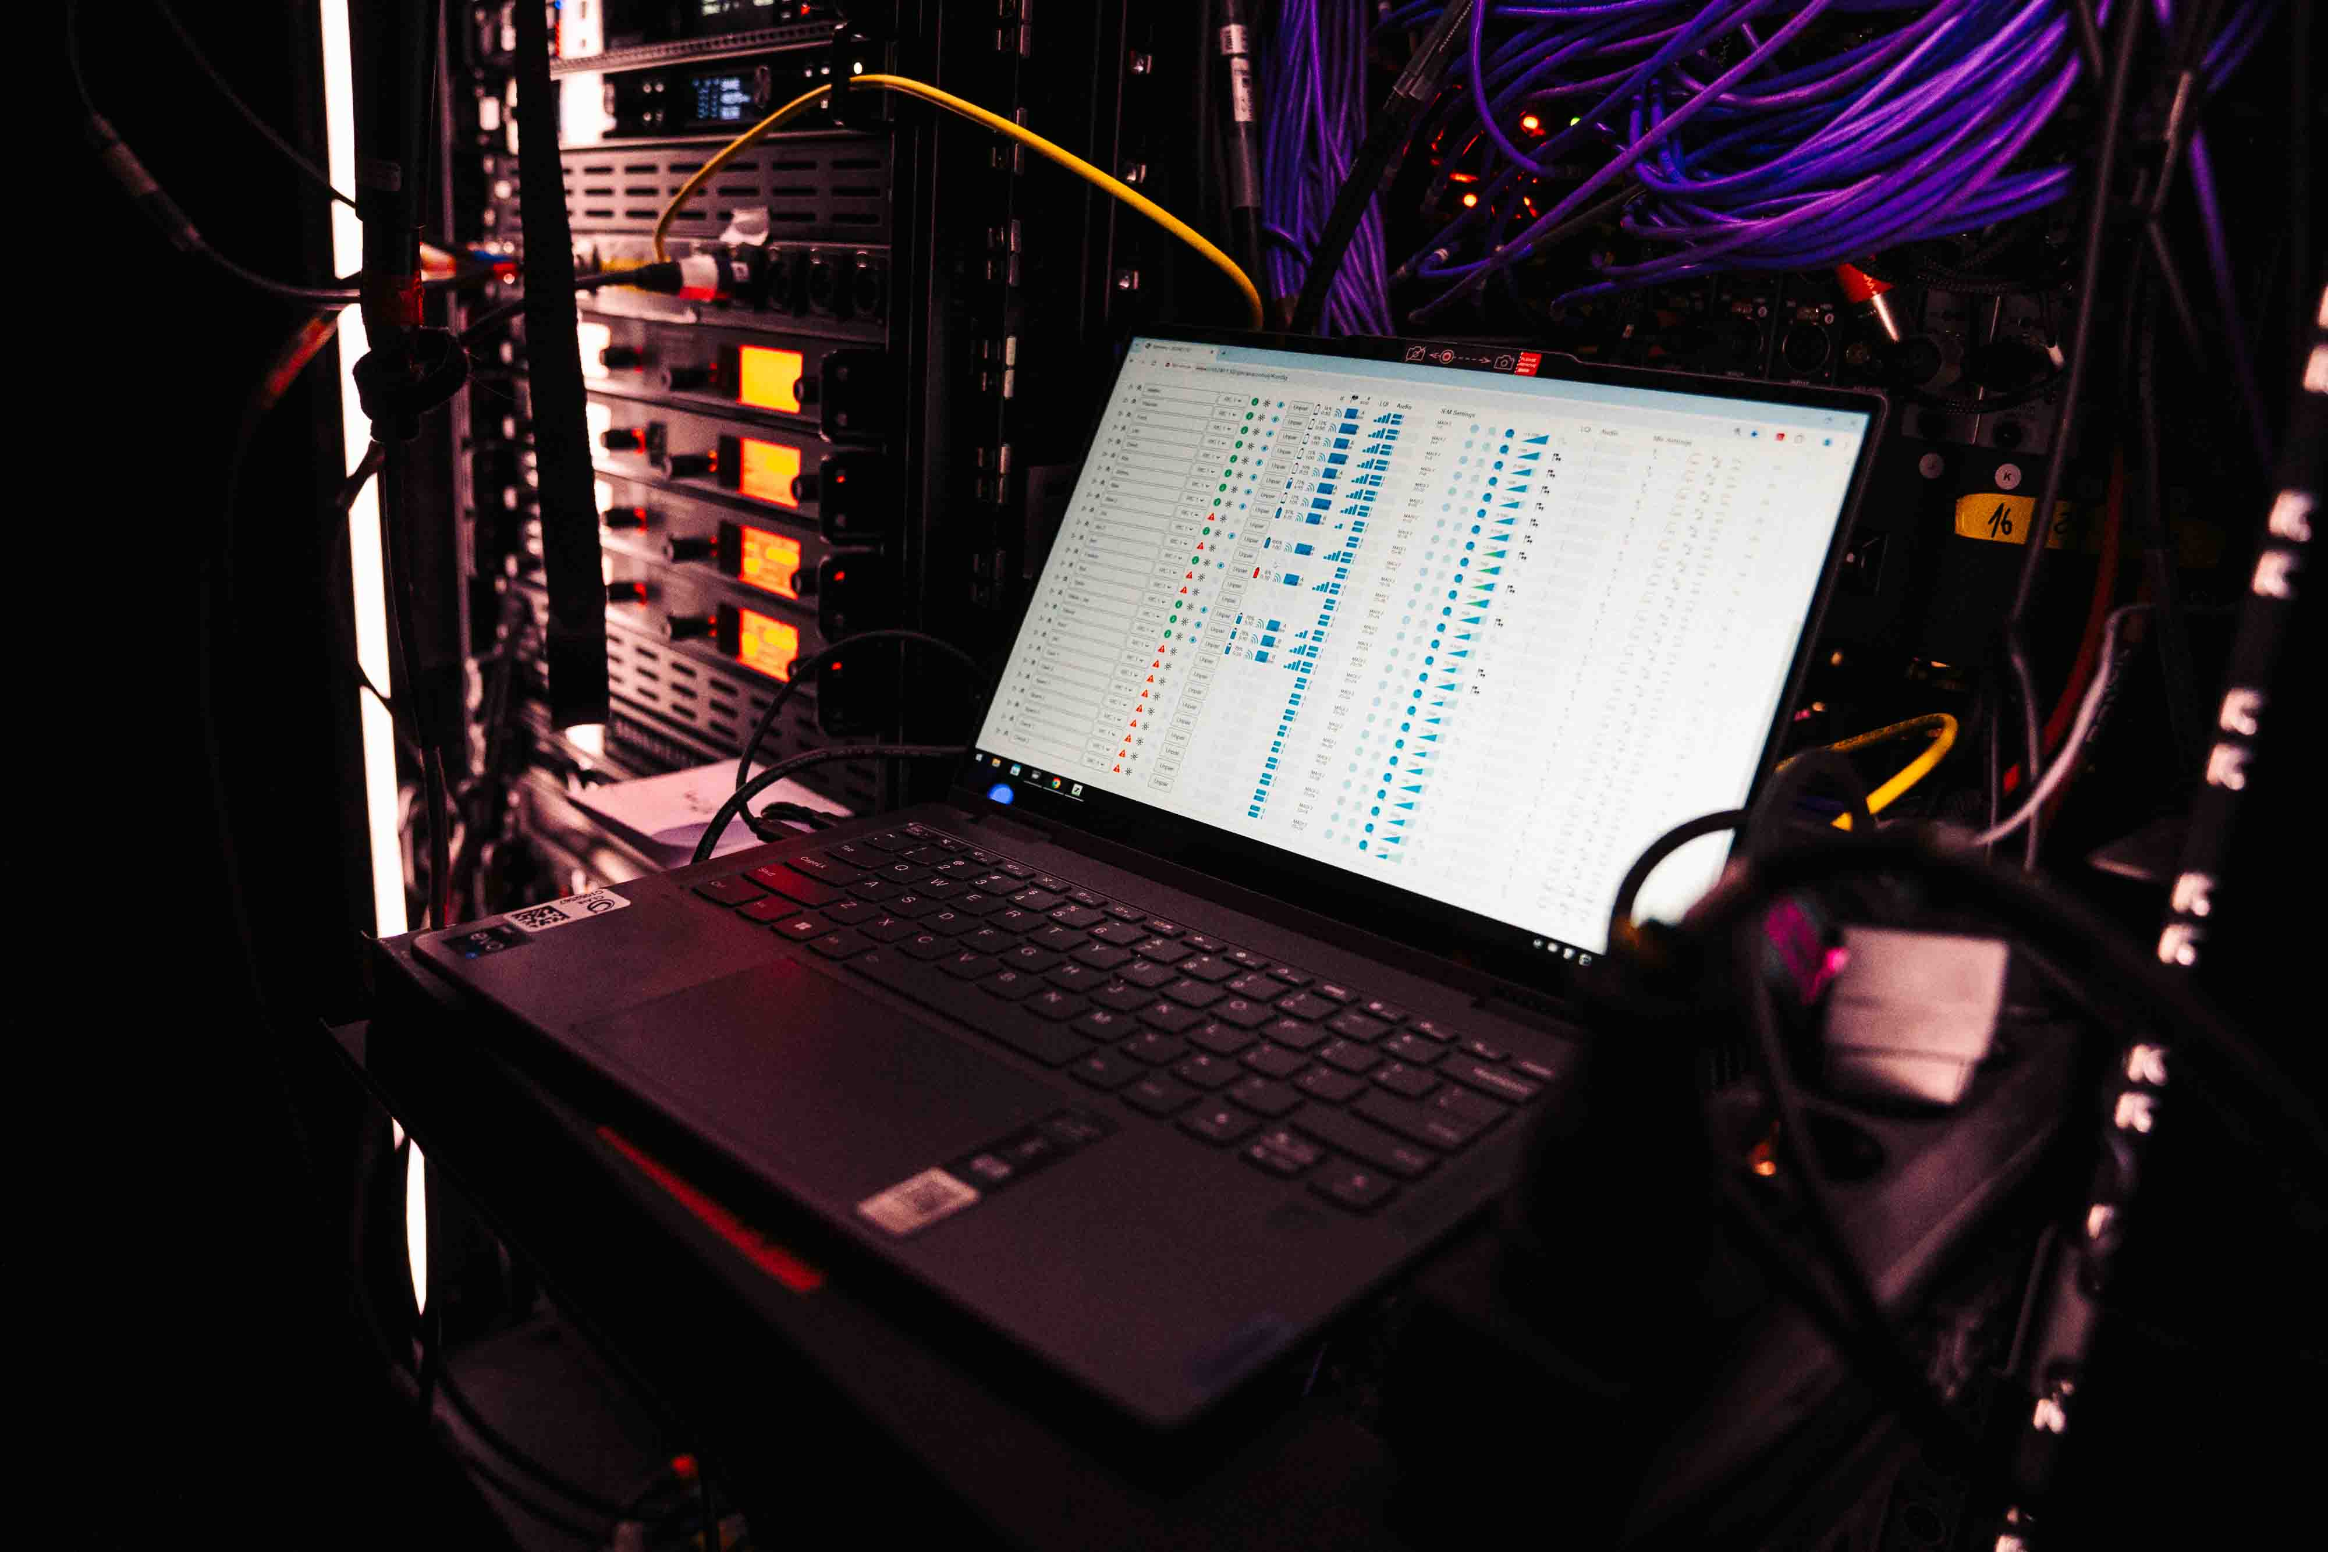

Global regulatory and certification status
Spectera has obtained full regulatory approval and product certification in the EU-27 countries, the UK, Switzerland, Norway, Greenland, Qatar, the UAE, the USA, Canada, Australia (indoor use, outdoor pending), Singapore, Malaysia, the Philippines, Indonesia, Hong Kong, and New Zealand (510-606 MHz). Regulatory approval has been granted in South Africa, Egypt, Israel, Rwanda, Kenya, Nigeria, Mexico, Taiwan and Bhutan, with certification still pending. Certification is also pending in India, where a regulatory ruling is not in place. For updates, please visit the Sennheiser Frequency Advisor Tool | Sennheiser.

Product registration, idea hub and roadmap
By registering their Spectera in the Sennheiser customer portal, users will receive notification for software updates and release notes, and can always stay up to date with what is new for the ecosystem. From May, registration is open at my.sennheiser.com. The portal also hosts an idea space where customers and operators can submit the features and functionalities they would like to see implemented with Spectera. Users can also comment on submitted ideas, and upvote or downvote suggestions. All entries will be reviewed by product management and the technical teams. The Spectera roadmap in the portal will give customers an overview of what the team is working on right now, which features are targeted for implementation during the next six months, and what is part of the roadmap beyond that timeframe.

“The entire Spectera team are super-excited about the start of shipping,” shares Euen, “and are very much looking forward to further evolving the ecosystem together with our customers.”

(Ends)

The high-resolution images accompanying this media release can be downloaded here.

Spectera landing page: Spectera: The Future of Wireless Pro Audio | Sennheiser
General WMAS information: www.sennheiser.com/wmas
Media information on Spectera unveiling at IBC 2024: https://newsroom.sennheiser.com/sennheiser-spectera

About the Sennheiser brand
We live and breathe audio. We are driven by the passion to create audio solutions that make a difference. Building the future of audio and bringing remarkable sound experiences to our customers – this is what the Sennheiser brand has represented for more than 75 years. While professional audio solutions such as microphones, meeting solutions, streaming technologies and monitoring systems are part of the business of Sennheiser electronic SE & Co. KG, the business with consumer devices such as headphones, soundbars and speech-enhanced hearables is operated by Sonova Holding AG under the license of Sennheiser.

www.sennheiser.com
www.sennheiser-hearing.com

Global Pro Audio Press Contact
Stephanie Schmidt
stephanie.schmidt@sennheiser.com
+49 (5130) 600 – 1275

